U.S. 89, PAGE, ARIZONA LANDSLIDE-2013-EXECUTIVE SUMMARY

# Overview:

On February 20, 2013 approximately 20 miles south of Page, Arizona, US-89 experienced landslide movement that displaced nearly 500 feet of travel lanes. The failure plane extends through the road and down along the embankment that the road sits on (Figure 1). The highway was immediately closed and geotechnical experts were brought on-site to assess the damage of the natural disaster and to propose mitigation plans.

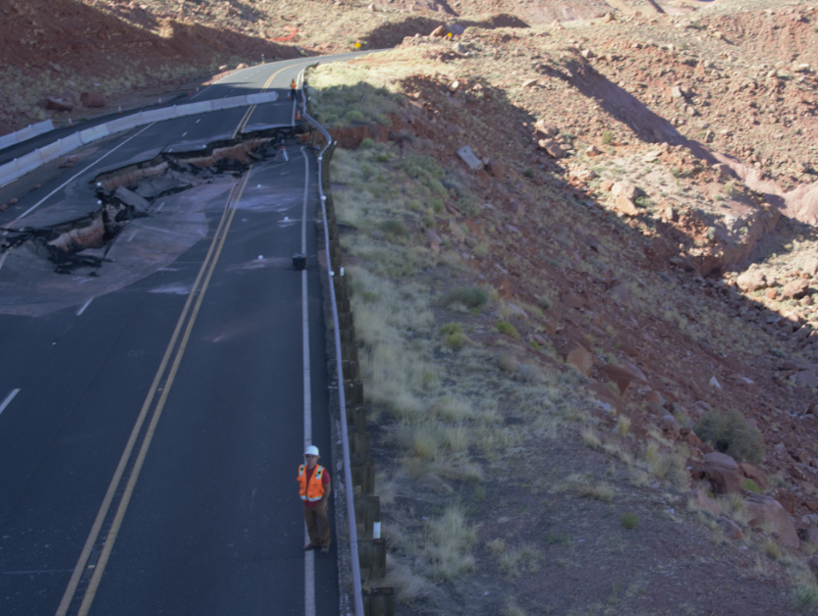

**Figure 1.** Failure plane of the landslide extending through the road.

According to the geotechnical engineers at Kleinfelder, their analysis indicated that the landslide is a reactivated portion of a larger, ancient translational (planar) landslide. The active landslide is up to approximately 135 feet deep below the roadway and measures approximately 1,200 long at the base (toe) of the slope. The ancient landslide is up to approximately 300- feet-thick and approximately 2,500 feet wide (as measured along Highway 89). While many slope failures are associated with the presence of water, the geotechnical report states, “Our subsurface explorations did not encounter groundwater seeps and we conclude that this recent failure occurred under ‘dry’ conditions due to long-term slope creep and slow but continual erosion at the base of the slope.” Kleinfelder suggests that the slope would continue to move if action was not taken to mitigate the landside. Kleinfelder proposed that “the most geotechnically feasible mitigation concept is to construct a gravity buttress at the base of the landslide slope and adjust the highway travel lanes farther to the east by creating a new back cut into the existing rock slope. This concept will move the highway away from the current headscarp of the landslide and will provide the needed fill materials to construct the buttress at the base of the slope.”

# References:

McCormick, W. V.; Richmond, J. C. Kleinfelder. *Geotechnical Assessment, Bitter Springs Landslide, US Highway 89*; Tempe, AZ, 2013.

Arizona Department of Transportation. “US Route 89 Landslide.” (2 Mar. 2015). <http://azdot.gov/projects/north-central/us-89-landslide/overview>.

"ADOT identifies long-term US 89 repair solution near Page." 2013. ADOT Media Center,

(April 7, 2013).<<http://azdot.gov/media/News/news-release/2013/07/10/adot-identifies-long-term-us-89-repair-solution-near-page>>